Report on Coronavirus survey in Italy: comparison of three waves

Ioana-Elena Oana and Hanspeter Kriesi

Stein Rokkan Chair and European Governance and Politics Program (Robert-Schumann Centre)
July 22, 2020

In this report, we present the evolution between March and June of public attitudes related to the COVID-19 pandemic in Italy. On the one hand, we report on the agreement and compliance with public health measures. On the other, we present the evolution of citizens’ satisfaction with the government in general, with the government’s response to the COVID-19 pandemic, and with EU’s handling of the crisis. The report is based on a representative three-wave panel survey conducted online by IPSOS on March 28-30, April 15-17, and June 21-28, 2020 on a total sample of 1665 respondents.

Agreement with government measures
Figure 1 shows that the various measures taken by the government to prevent the spread of the virus are widely accepted with more than 50 per cent of respondents agreeing with these measures in all three waves. Surprisingly, even in June, when Italy saw a considerable drop in cases and was already introducing relaxation measures, more than half of the citizens agreed with public health measures. The notable exception is surveillance by app which was the most unpopular measure in wave 1 and 2, and became even more unpopular in wave 3.
In what regards the evolution of agreement over time, if there was only a slight drop in agreement between March and April, this drop has accentuated from April to June, even if the agreement is still rather high. This is unsurprising considering the amelioration of the health situation and the introduction of relaxation measure. Agreement with schools and shops closing has dropped by more than 20 per cent, followed by agreement with travel bans and border closures that dropped by 14-15 per cent.

Figure 1: Agreement with measures, by wave

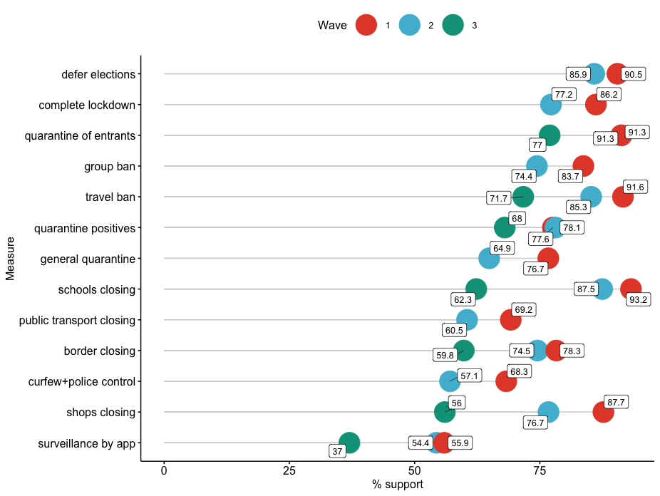

Compliance with the government health measures
Compliance with measures follows a similar pattern as agreement, as seen in Figure 2. The overall compliance with the government’s health measures even in June (wave 3) is still very high, with more than 50 per cent of respondents complying with all measures. The evolution over time is also unsurprising given the relaxation measures, with drops between 5 and 15 per cent for most measures between April and June. The notable exception in this case regards avoiding to see friends, which saw a 40 per cent drop in compliance, but is still respected by more than half of the citizens.

Figure 2: Compliance with measures, by wave
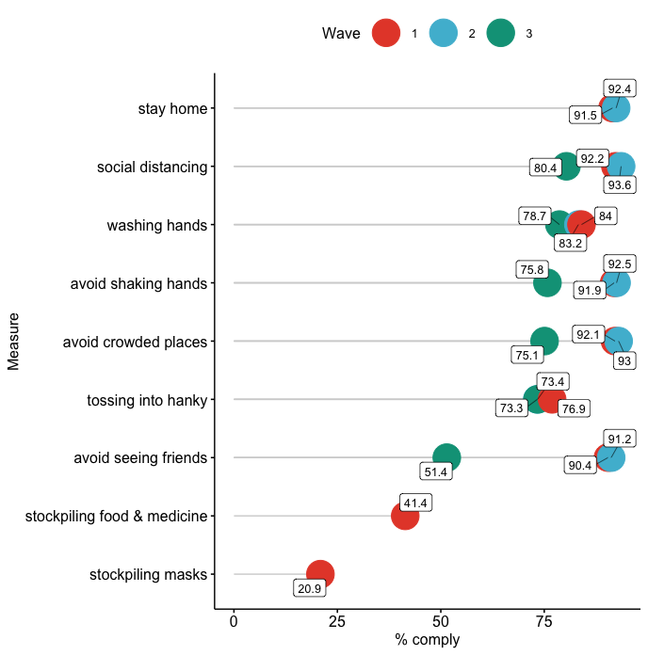
Overall assessment of the health and economic measures taken by the government
Figure 3 shows the evolution of citizens’ perception of the seriousness of the health and economic consequences of the crisis and their general evaluation of the government’s response in these two aspects. We see that while in March and April, citizens appeared to be equally concerned about the health and economic consequences of the crisis (with a slightly higher concern for the economy), in June the gap between health and economic worries widened substantially. While economic concerns remained high, with about 87 per cent of respondents considering the crisis will have significant economic consequences, health concerns dropped by 27 per cent since April to about 60 per cent.
A similar pattern can be observed in what regards the evaluation of health and economic measures taken by the government. If the number of those who consider the economic response insufficient remains rather high (57.2 per cent) and even increased slightly since spring, the health response evaluation improved. Therefore, in June less than 20 per cent of respondents considered the health response insufficient, compared to 25.5 per cent in April and 34.4 per cent in March.

Figure 3: Shares of Italians considering the public health and economic consequences of the crisis as serious and the public health and economic response insufficient

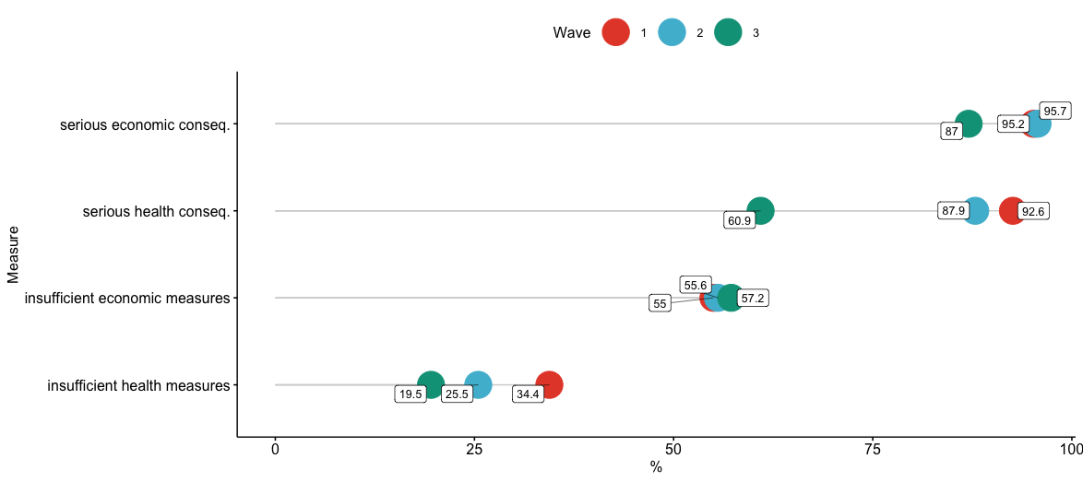

Figure 4: Shares of Italians who consider public health and economic response insufficient, by political camp

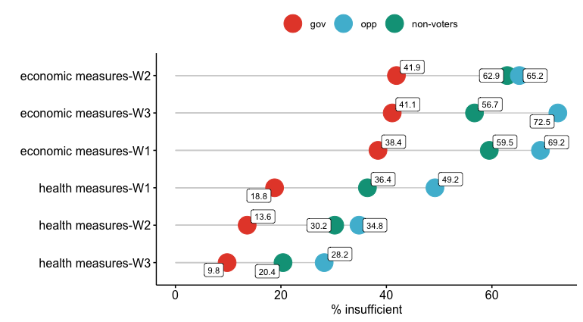

Overall satisfaction with how the government and the EU handled the crisis
When it comes to satisfaction with the government in general, there are very small fluctuations indicating a small decrease in satisfaction from the height of the pandemic in March (59.75 overall satisfaction), and then to April (57.07 per cent) and June (56.18 per cent). Nevertheless, satisfaction with government remains very dependent on political camp, with more than 80 per cent of respondents aiming to vote for the government being satisfied, compared to only a third of prospective opposition voters (see Figure 5).
Interestingly, satisfaction with how the EU handled the crisis is also highly dependent on political camp (see Figure 6), with opposition voters being the most dissatisfied, followed by non-voters. Nevertheless, dissatisfaction with the EU dropped massively in between April and June across all three political camps. An explanation for this drop lies in the highly conflictual discussions at the EU level in mid-spring surrounding the introduction of coronabonds, Italy’s preferred instrument of EU solidarity. As the EU further put on the table more proposals for instruments to come at the aid of the worst-hit countries throughout May and June, dissatisfaction with its handling of the crisis appears to have heavily subsided across all three political camps in Italy.
Figure 5: overall satisfaction with the government, by political camp

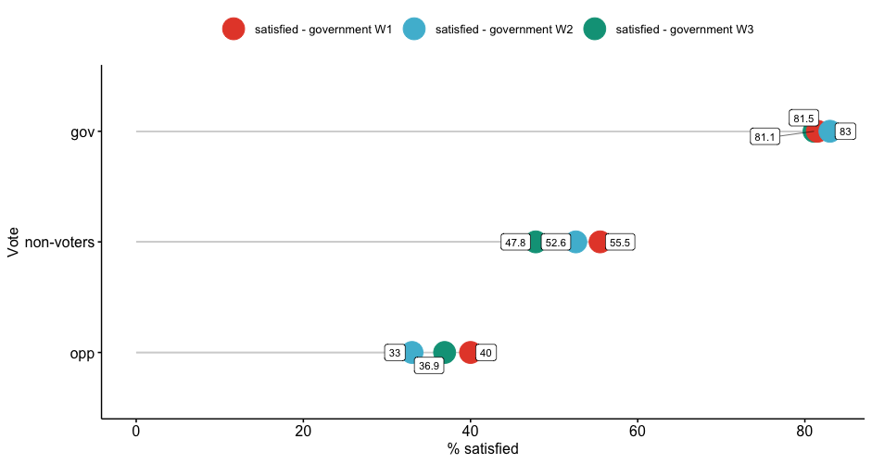

Figure 6: dissatisfaction with how the EU handled the crisis by political camp
